

**17 JUNE 2025**

Ukraine’s Uncrewed Air and Ground Systems Teaming Marks a Watershed Moment

*Dorsel D. Boyer II, TRADOC Military Analyst*

***In December 2024, Ukraine’s 13th KHARTIIA Ukrainian National Guard Brigade, known as the “Charter Brigade,” conducted its first uncrewed combined-arms assault using a coordinated force of remote-controlled flying surveillance and minelaying drones, air and ground one-way explosive robots, as well as armed ground robots.*** This operation targeted Russian positions near the city of Hlyboke in Ukraine’s Kharkiv Oblast that Russian assault groups were using as mission support sites as they targeted Ukrainian positions (see Figure 1).1 The Charter Brigade opted for this approach to defend against four Russian regiments, after having successfully integrated unmanned ground vehicles (UGVs) with unmanned aircraft systems (UAS) in its defensive operations in September 2023.

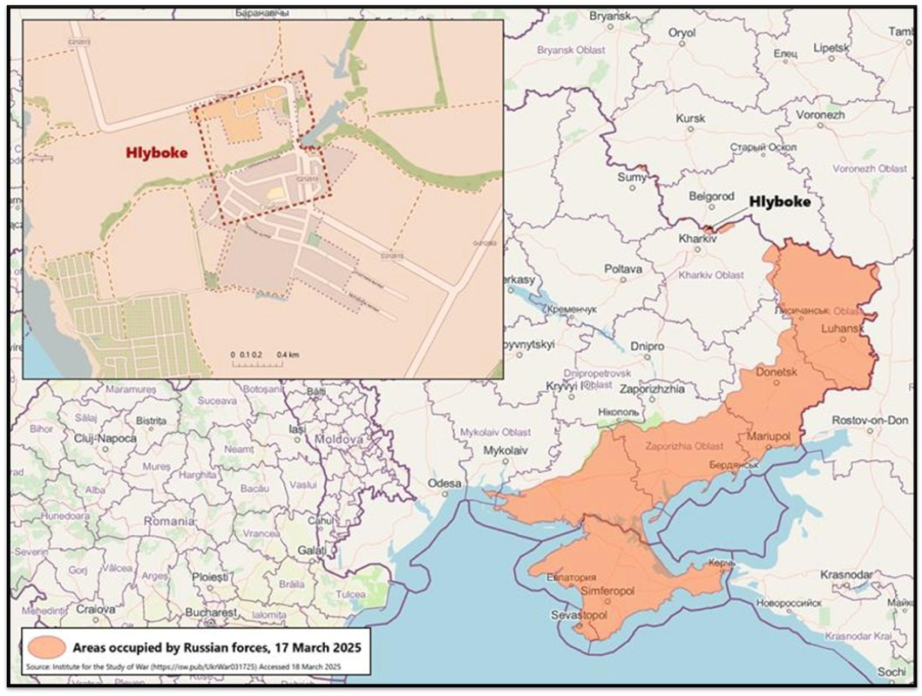

*Figure 1: Hlyboke, near the northern border of Kharkiv Oblast (Source: TRADOC G-2)*

***"Know The enemy"***

**HTTPS://OE.TRADOC.ARMY.MIL/CATEGORY/RED-DIAMOND-POSTS**

U.S. Army

Training and Doctrine Command, G-2

***Red Diamond***

***The Charter Brigade’s coordinated assault on Russian forces employed various strategies, including minelaying, surveillance, and precision targeting.*** The Charter Brigade deployed more than 50 unmanned systems against Russian forces, including armed UGVs, multirotor UAS, and first-person view (FPV) drones. While the specific types of unmanned systems remain unconfirmed, reports highlight the use of Droid TW UGVs armed with .50 caliber machine guns, as well as the use of Ratel S UGVs equipped with TM 62 antitank mines as ‘suicide drones’ meant to detonate in Russian hardpoints.2 The Charter Brigade used larger multirotor UAS for additional support, conducting minelaying operations, relaying communications, and conducting surveillance. Smaller FPV drones provided precise targeting for the UGVs, enabling the coordinated assault.3

***This uncrewed combined-arms approach allowed the Charter Brigade to successfully dislodge Russian forces from their positions without risking Ukrainian soldiers’ lives.*** Ukrainian soldiers were still required, however, to secure and hold the captured territory, highlighting the enduring need to pair unmanned assaults with ground forces to fully exploit the shock of the unmanned attack.4 The brigade’s success stemmed from extensive rehearsals, ensuring drone operators responsible for multiple platforms could coordinate movement and fires and that modified systems were able to traverse the difficult terrain.5 While two unmanned systems were lost due to inability to navigate the muddy terrain, no systems were lost due to Russian fire, indicating successful suppression of Russian air defenses.6

***Ukraine’s all-robot operation marks a significant step forward in demonstrating the viability of purely unmanned assaults.*** This operation built on previous successes using unmanned systems teaming in support of soldiers, such as pairing the Ironclad, a four-wheeled UGV developed by Roboneers, with UAS for observation fire support in defensive operations.7 In 2024, Ukraine started arming the Ironclad UGV with automatic grenade launchers to provide support to the 5th Ukrainian Assault Brigade.8 As Ukrainian forces gained experience, the 8th Ukrainian Special Purpose Regiment teamed a Fury UGV with special operations forces to clear a Russian trench during an assault in Kursk.9

## Planning for the December operation began in July 2024, with the Charter Brigade focusing on crucial aspects of unmanned warfare: maintenance and training, electronic warfare and terrain analysis, and artificial intelligence (AI) integration for targeting support.

* **Maintenance and Training.** Early experience with UGVs in the assault role highlighted the need for additional maintenance and training to ensure the unmanned systems team was prepared for the operation.10
* **Electronic Warfare and Terrain Analysis.** The Charter Brigade analyzed enemy positions through electronic warfare (EW) and terrain assessments to identify suitable routes for unmanned systems operations, highlighting the importance of understanding the EW environment and conducting thorough evaluations of terrain for mission planning with UGVs.11
* **AI Integration for Enhanced Targeting.** The expanded use of unmanned systems revealed human limitations in processing, exploiting, and disseminating the volume of information collected. Ukraine addressed this limitation by pairing AI-enabled targeting systems to the unmanned systems to enable the latter to efficiently engage targets and support movement to the target with limited human intervention, known as last-mile navigation.12

# https://oe.tradoc.army.mil/category/red-diamond-posts 2

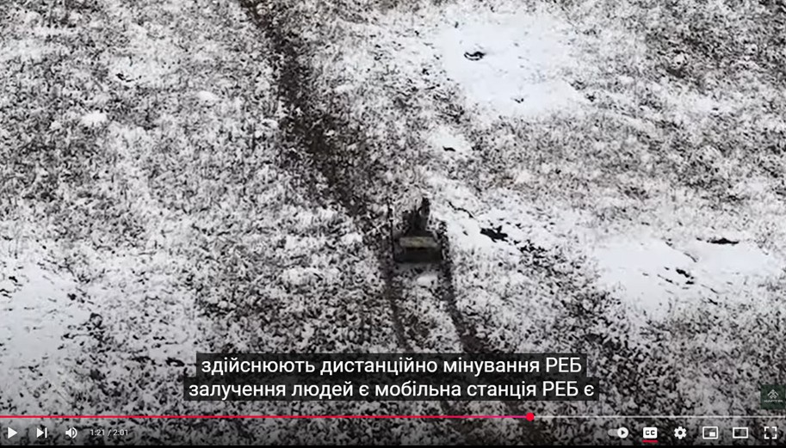

*Figure 2: Droid TW overwatched by UAS (Source: Charter-13 National Guard of Ukraine Facebook page)*13

# Implications for Large-Scale Combat Operations

## The conflict in Ukraine has become a proving ground for unmanned warfare, offering lessons for the

***U.S. Army as it prepares for future large-scale combat operations (LSCO).*** The widespread use of unmanned systems by both sides underscores their growing importance and highlights key areas for adaptation.

***The U.S. Army can expect to operate in environments densely populated by uncrewed systems and proliferated across the breadth and depth of the LSCO battlefield.*** Ukraine’s armed forces have effectively used unmanned systems to counteract Russia’s advantages, proving their effectiveness in air and maritime operations. China’s People’s Liberation Army (PLA) has noted the success of these systems and sees their integration with conventional systems as part of an “undeniable trend” toward “intelligentized warfare.”14 China aims to create an AI-enabled system that combines small UAS with key platforms like the VT4A1 main battle tank.15 The PLA views the adoption of unmanned systems as a cost- effective strategy for area denial and large-scale assaults on air defenses, drawing lessons from Russia’s experiences in the conflict against Western-supplied weaponry.

## While UGVs’ effectiveness can be hindered by terrain and line-of-sight limitations for ground control stations, Ukraine has mitigated these issues by teaming UGVs with UAS for route reconnaissance. The

U.S. Army can learn from Ukraine’s example and team UGV with UAS, conduct detailed terrain analysis, and apply AI for better navigation and target acquisition to mitigate complex terrain challenges.

***The 2023 Ukrainian counteroffensive highlighted the difficulties of breaching fortified defenses, suggesting improved coordination between ground and aerial systems could enhance effectiveness.*** Integrating UGVs equipped with advanced sensors such as LIDAR, mine-clearing line charges, or mine- detonating rollers into engineer units could help clear the path while reducing the risk to Soldiers.

# https://oe.tradoc.army.mil/category/red-diamond-posts 3

**ENDNOTES**



**U.S. Army Training and Doctrine Command, G-2 (TRADOC G-2)**

**Ft. Leavenworth, KS 66027 · Fort Eustis, VA 23604**

**HTTPS://OE.TRADOC.ARMY.MIL/CATEGORY/RED-DIAMOND-POSTS**

*The TRADOC G-2’s mission is the Operational Environment. We create the conditions necessary to research it; we define it; we understand it; we apply it; and we export it. We know the enemy and make sure our customers do too.*

4

APPROVED FOR PUBLIC RELEASE. DISTRIBUTION IS UNLIMITED

1. Kateryna Serohina, Ukrainian National Guard Soldiers Conduct First Robotic Operation, RBC-Ukraine (December 17, 2024) hxxps://newsukraine.rbc.ua/news/ukrainian-national-guard-soldiers-conduct-1734407482.html; David Axe, Ukraine’s All- Robot Assault Force Just Won Its First Battle, Forbes (December 21, 2024) ht[tps://www.forbes.com/sites/davidaxe/2024/12/21/](http://www.forbes.com/sites/davidaxe/2024/12/21/) ukraines-first-all-robot-assault-force-just-won-its-first-battle/
2. Defense Express, Western Media Write About a Unique Tactical Operation of Robotic systems Conducted by the Ukrainian Military Against Russians, Defense Express (January 25, 2025) hxxps:// en.defence-ua.com/weapon_and_tech/western_ media_write_about_a_unique_tactical_operation_of_robotic_systems_conducted_by_the_ukrainian_military_against_ russians-13315.html
3. Alistair MacDonald, All-Robot Assault Opens New Chapter in Front-Line Warfare, Wall Street Journal (March 18, 2025) hxxps:// [www.msn.com/en-us/news/world/all-robot-assault-opens-new-chapter-in-front-line-warfare/ar-AA1B7MDj](http://www.msn.com/en-us/news/world/all-robot-assault-opens-new-chapter-in-front-line-warfare/ar-AA1B7MDj)
4. Alistair MacDonald, All-Robot Assault Opens New Chapter in Front-Line Warfare, Wall Street Journal (March 18, 2025) hxxps:// [www.msn.com/en-us/news/world/all-robot-assault-opens-new-chapter-in-front-line-warfare/ar-AA1B7MDj](http://www.msn.com/en-us/news/world/all-robot-assault-opens-new-chapter-in-front-line-warfare/ar-AA1B7MDj)
5. Daniel Kosoy, Ukraine Conducts the First-Ever Assault Done Exclusively with Drones, United24 (February 7, 2025) hxxps:// united24media.com/war-in-ukraine/ukraine-conducts-the-first-ever-assault-done-exclusively-with-drones-5705
6. Daniel Kosoy, Ukraine Conducts the First-Ever Assault Done Exclusively with Drones, United24 (February 7, 2025) hxxps:// united24media.com/war-in-ukraine/ukraine-conducts-the-first-ever-assault-done-exclusively-with-drones-5705
7. Defense Express, Ukrainian Ironclad UGV Helps in Assault Operations and Provides Fire Support on the Frontline, Defense Express (September 23, 2023) hxxps://en.defence-ua.com/weapon_and_tech/ukrainian_ironclad_ugv_helps_in_assault_ operations_and_provides_fire_support_on_the_frontline-8033.html
8. Defense Express, Ukrainian Ironclad UGV Blasts Russian Position with Volley of Grenades, Defense Express (January 12, 2024) hxxps://en.defence-ua.com/weapon_and_tech/ukrainian_ironclad_ugv_blasts_russian_position_with_volley_of_ grenades_video-9164.html
9. David Axe, Ukraine’s Gun-Armed Ground Robot Just Cleared a Russian Trench in Kursk, Forbes (September
10. Kateryna Serohina, Ukrainian National Guard Soldiers Conduct First Robotic Operation, RBC-Ukraine (December 17, 2024) hxxps://newsukraine.rbc.ua/news/ukrainian-national-guard-soldiers-conduct-1734407482.html
11. Yuri Marchenko, Ukraine’s First Robot-Only Assault-Meet the Fighters who Pulled It Off, United24 (March 3, 2025) https: // united24media.com/war-in-ukraine/ukraines-first-robot-only-assault-meet-the-fighters-who-pulled-it-off-6375
12. Kateryna Bondar, Ukraine’s Future Vision and Current Capabilities for Waging AI-Enabled Autonomous Warfare, CSIS (March 6, 2025) hxxps:// [www.csis.org/analysis/ukraines-future-vision-and-current-capabilities-waging-ai-enabled-autonomous-](http://www.csis.org/analysis/ukraines-future-vision-and-current-capabilities-waging-ai-enabled-autonomous-) warfare#h2-conclusion
13. Charter-13, Головне – зберегти людей»: «Хартія» провела повністю роботизовану операцію, Хартія - 13 Бригада Національної гвардії України Youtube (January 2025) hxxps:// [www.youtube.com/watch?v=vabBDROkHD0&t=70s](http://www.youtube.com/watch?v=vabBDROkHD0&t=70s)
14. Tye Graham and Peter W. Singer, How China is Adopting Battlefield Lessons from Ukraine, Defense One (December 16, 2024) hxxps:// [www.defenseone.com/ideas/2024/12/how-china-adopting-battlefield-lessons-ukraine/401694/](http://www.defenseone.com/ideas/2024/12/how-china-adopting-battlefield-lessons-ukraine/401694/)
15. Tye Graham and Peter W. Singer, How China is Adopting Battlefield Lessons from Ukraine, Defense One (December 16, 2024) hxxps:// [www.defenseone.com/ideas/2024/12/how-china-adopting-battlefield-lessons-ukraine/401694/](http://www.defenseone.com/ideas/2024/12/how-china-adopting-battlefield-lessons-ukraine/401694/)